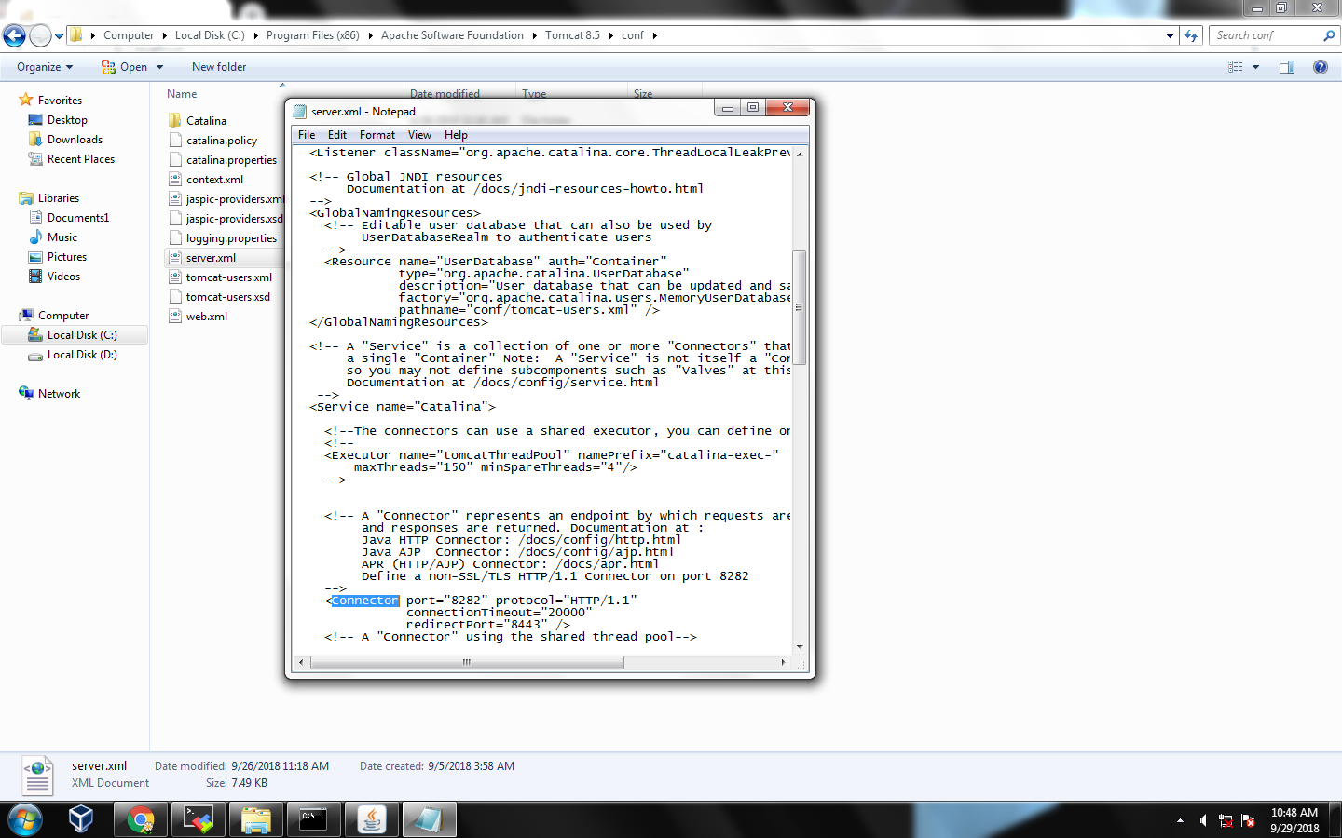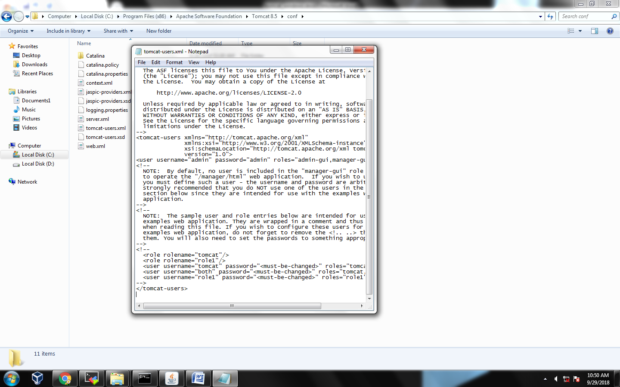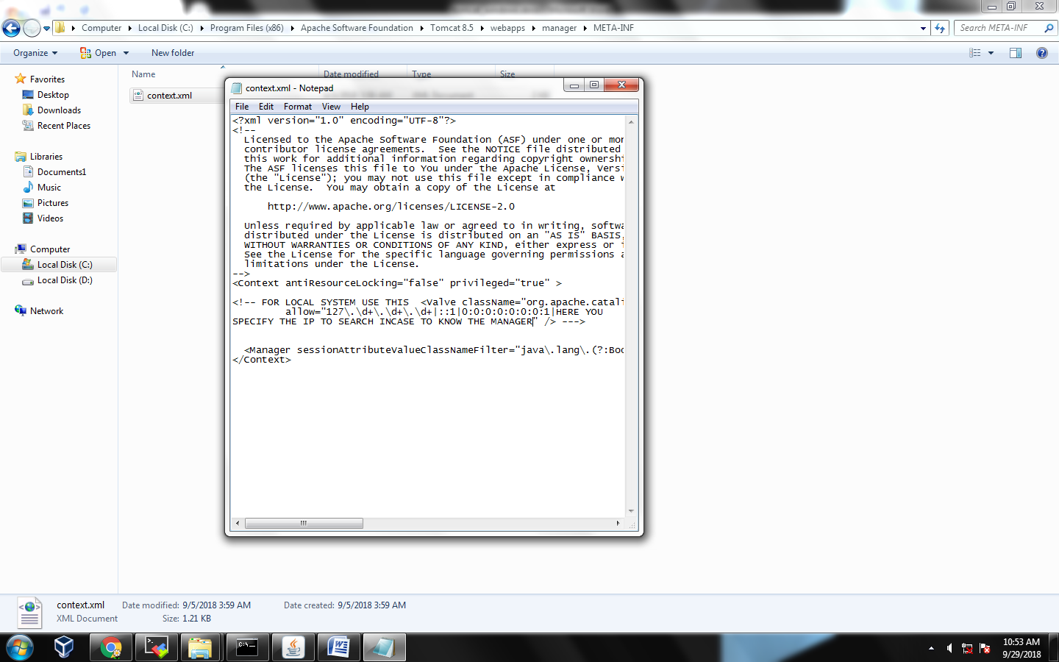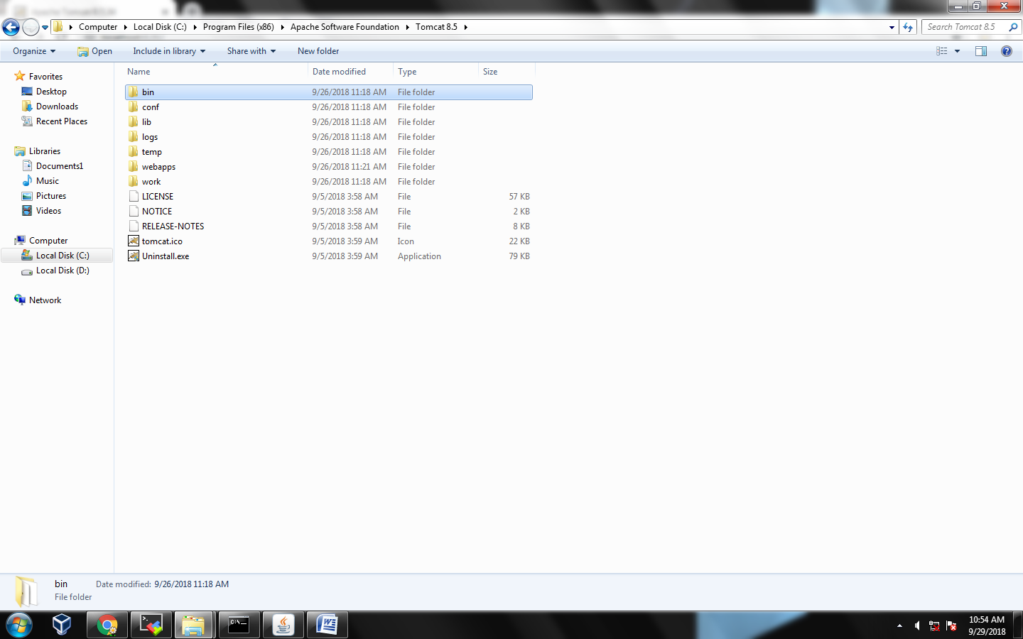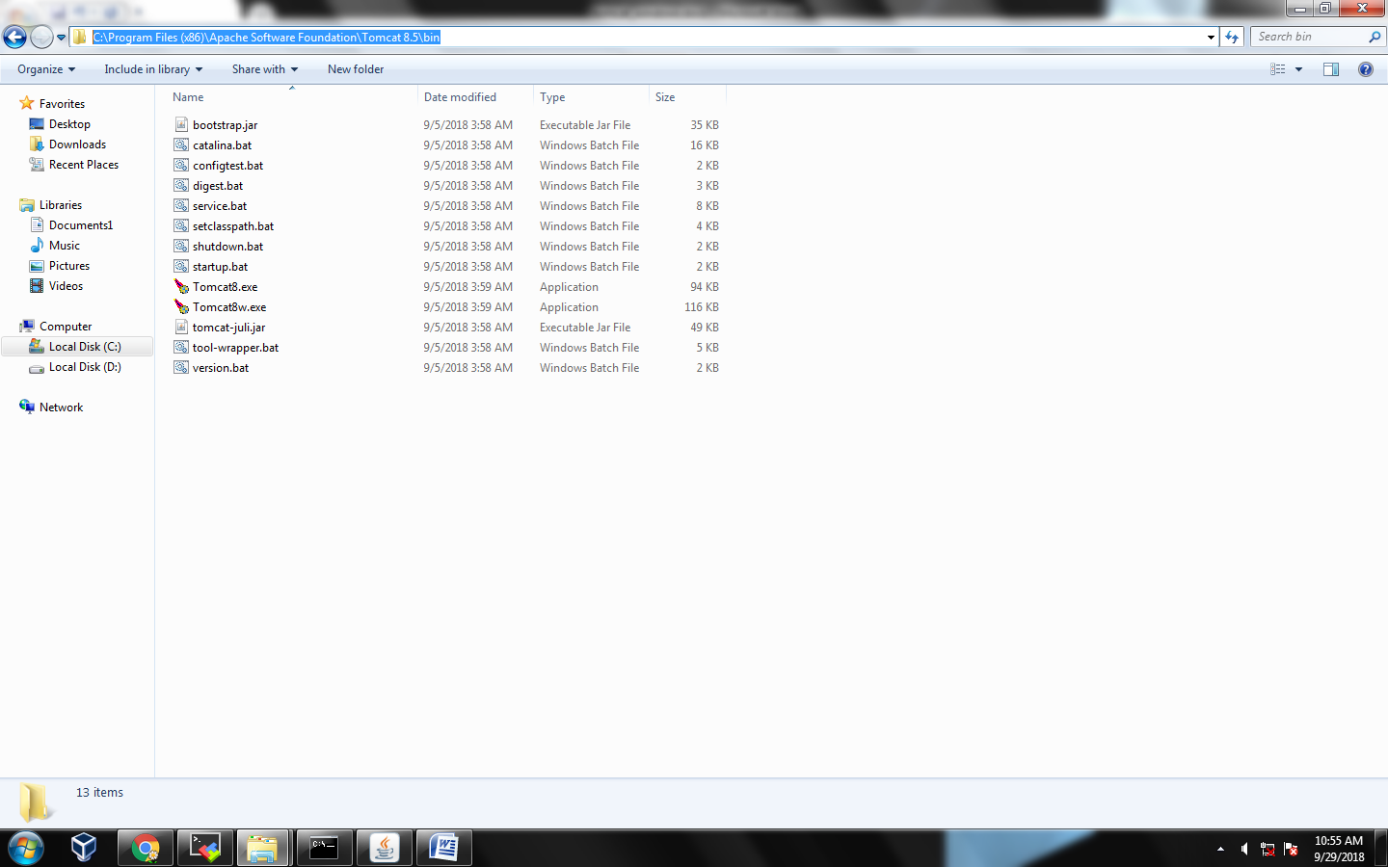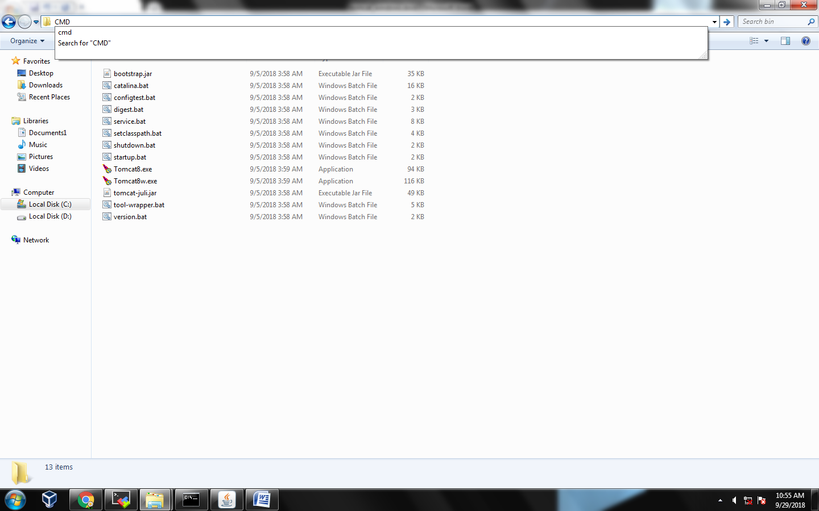

PRESS ENTER TO GOTO CMDON THIS LOCATION

C:\Program Files (x86)\Apache Software Foundation\Tomcat 8.5\bin

STARTUP.BAT

************************** SETTING JAVA PATH*******************************

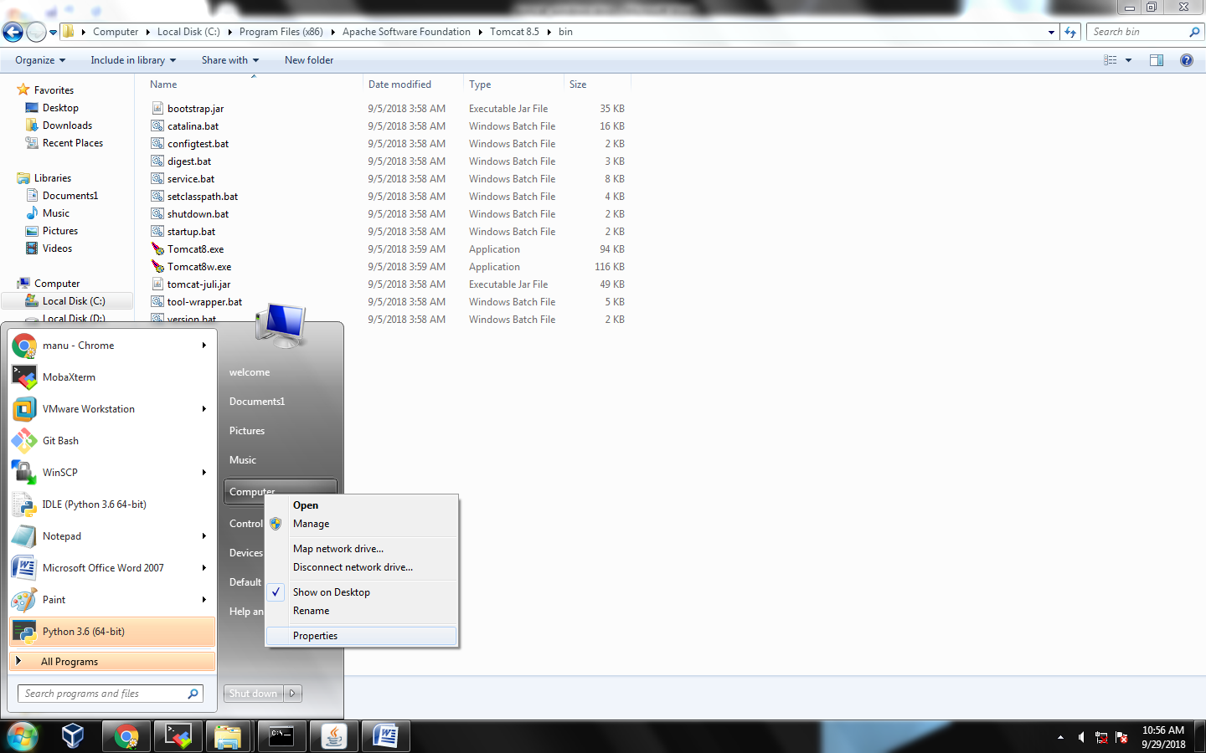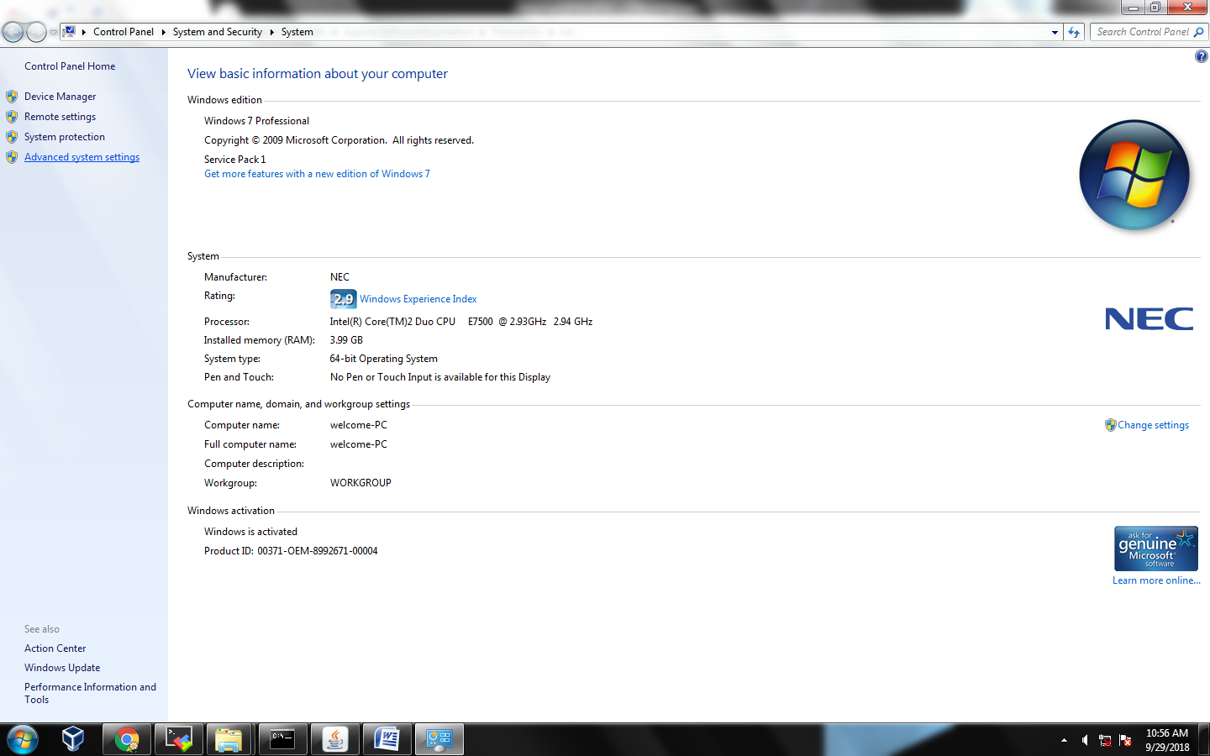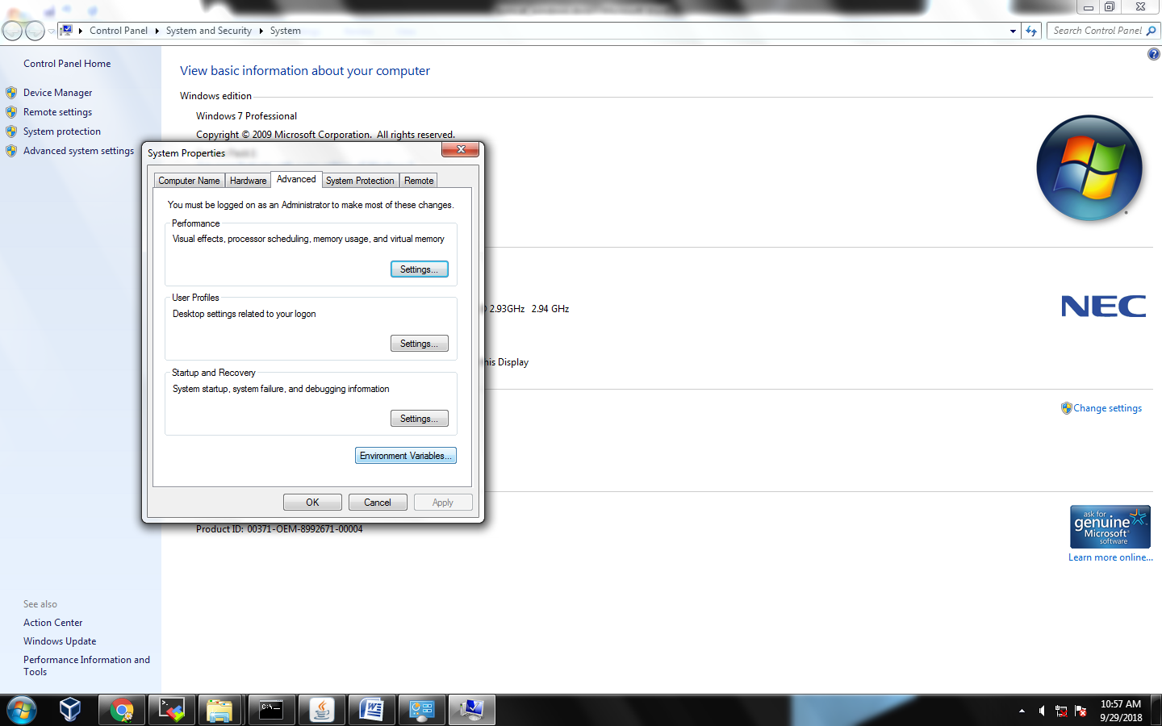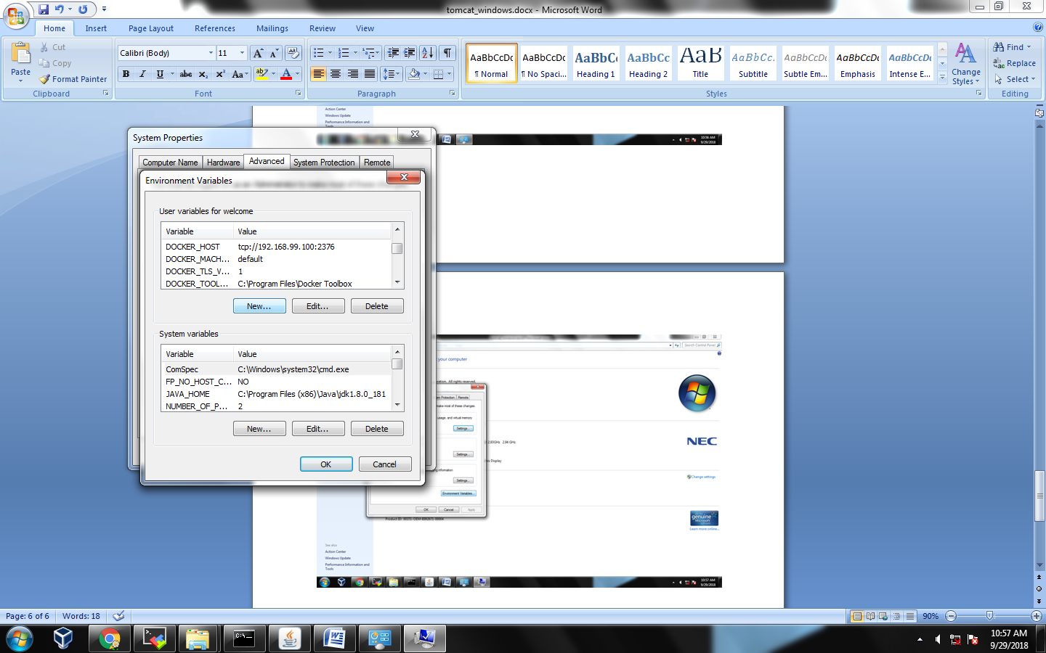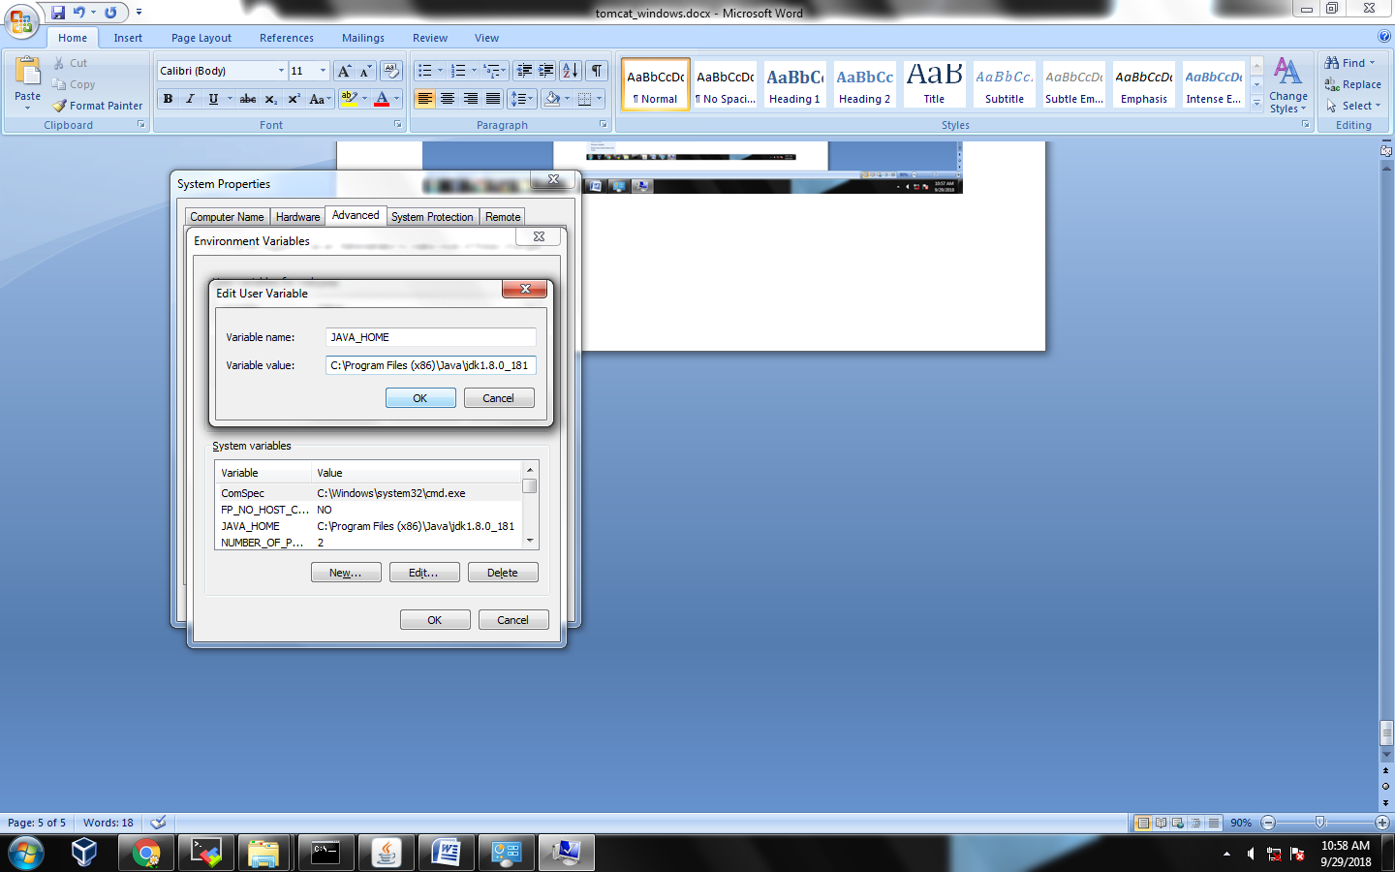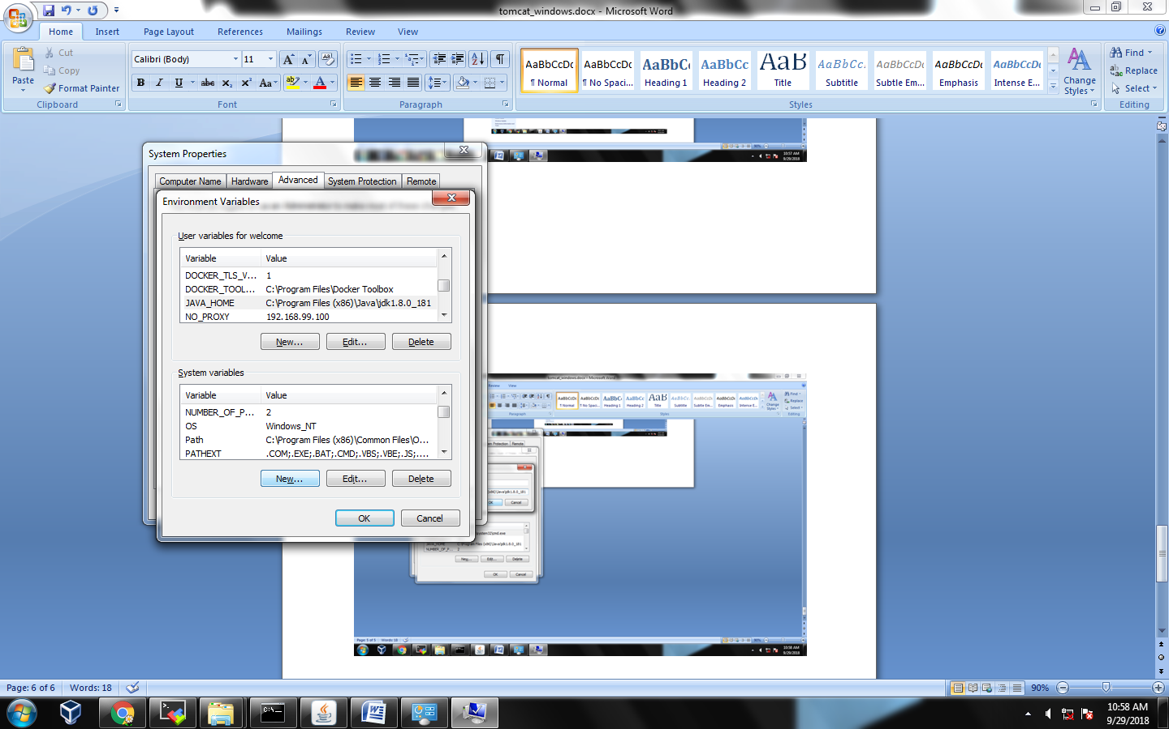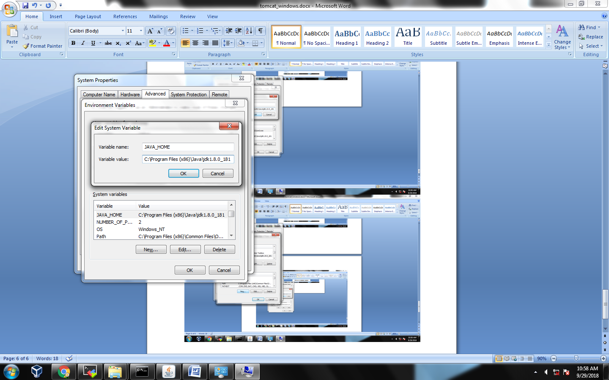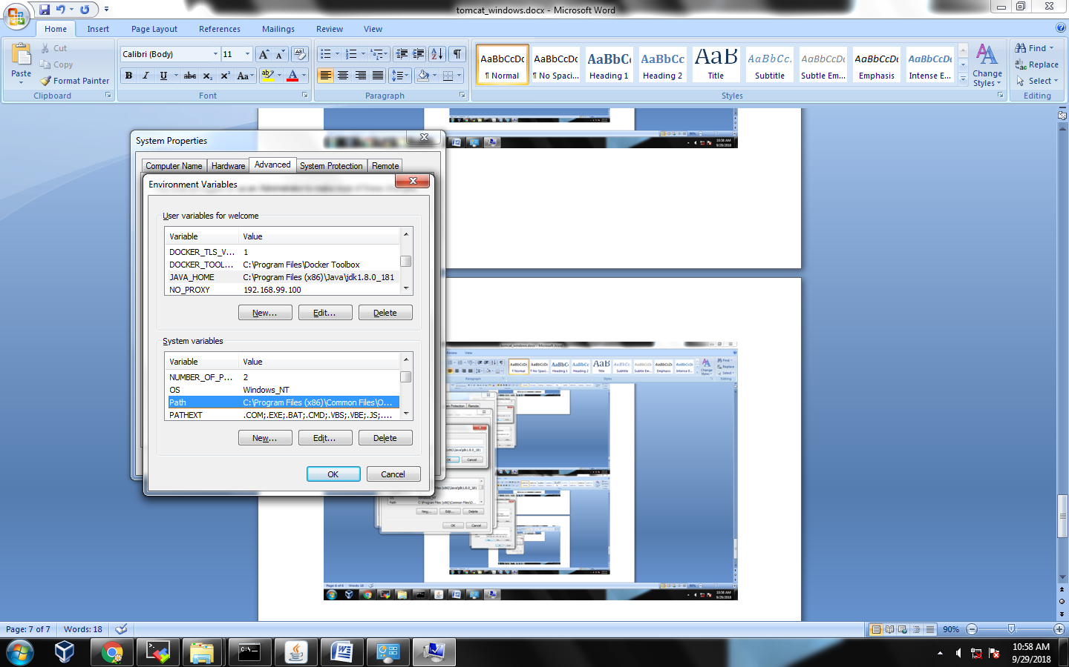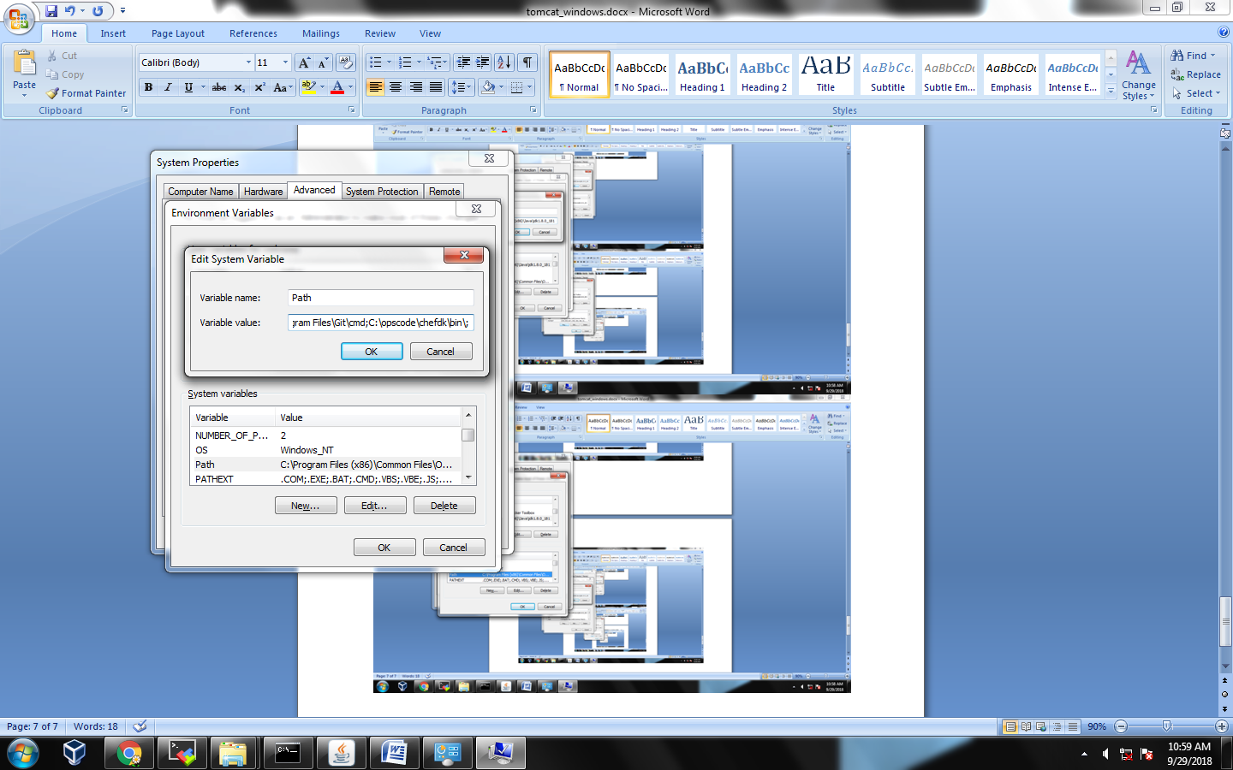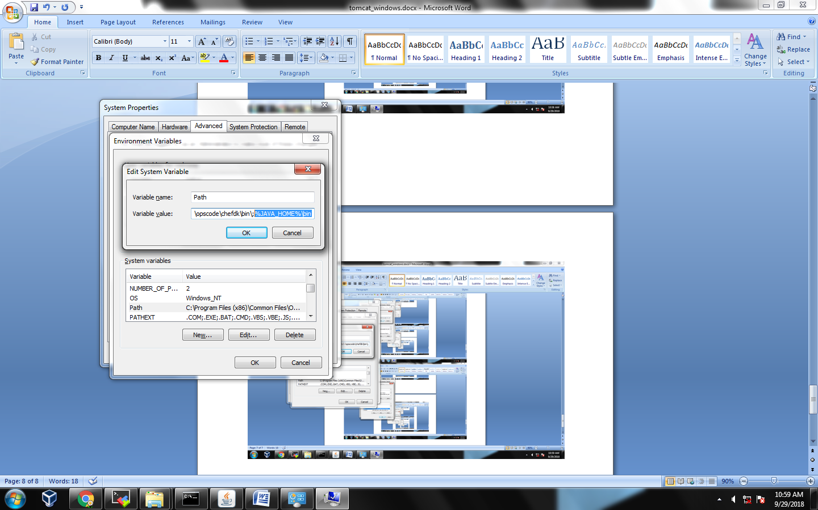

**************** WORKING ON LOCAL *********************************************

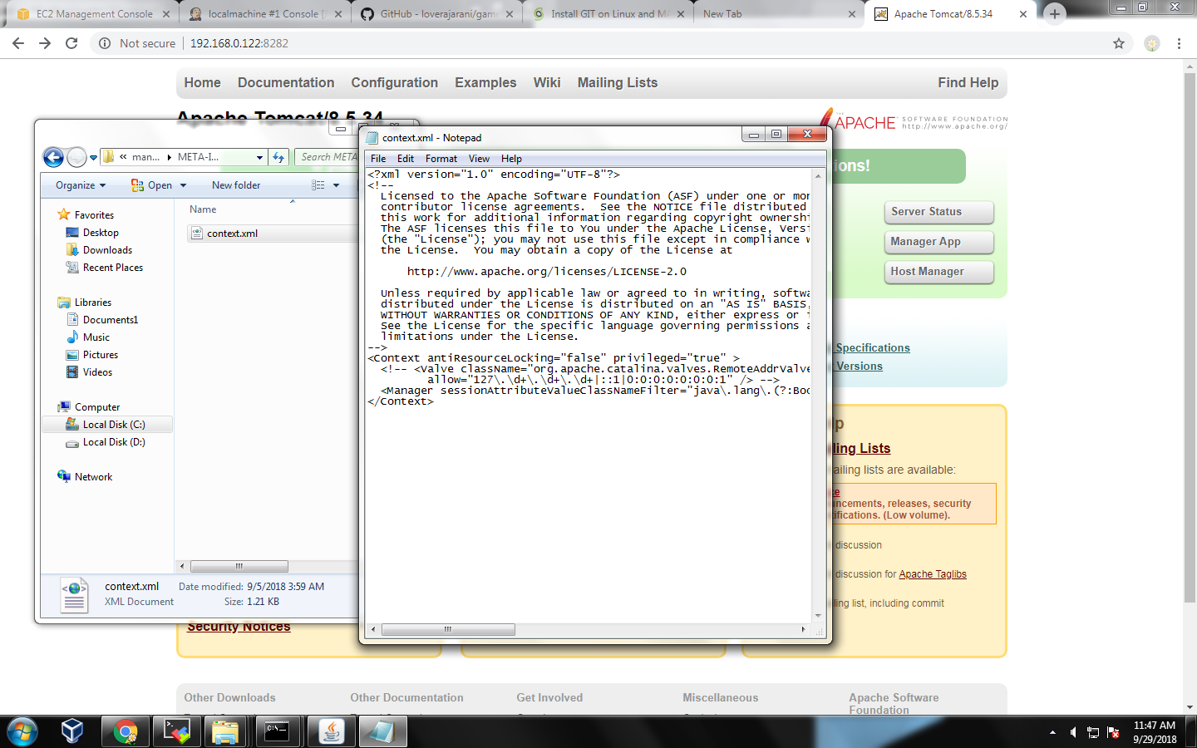

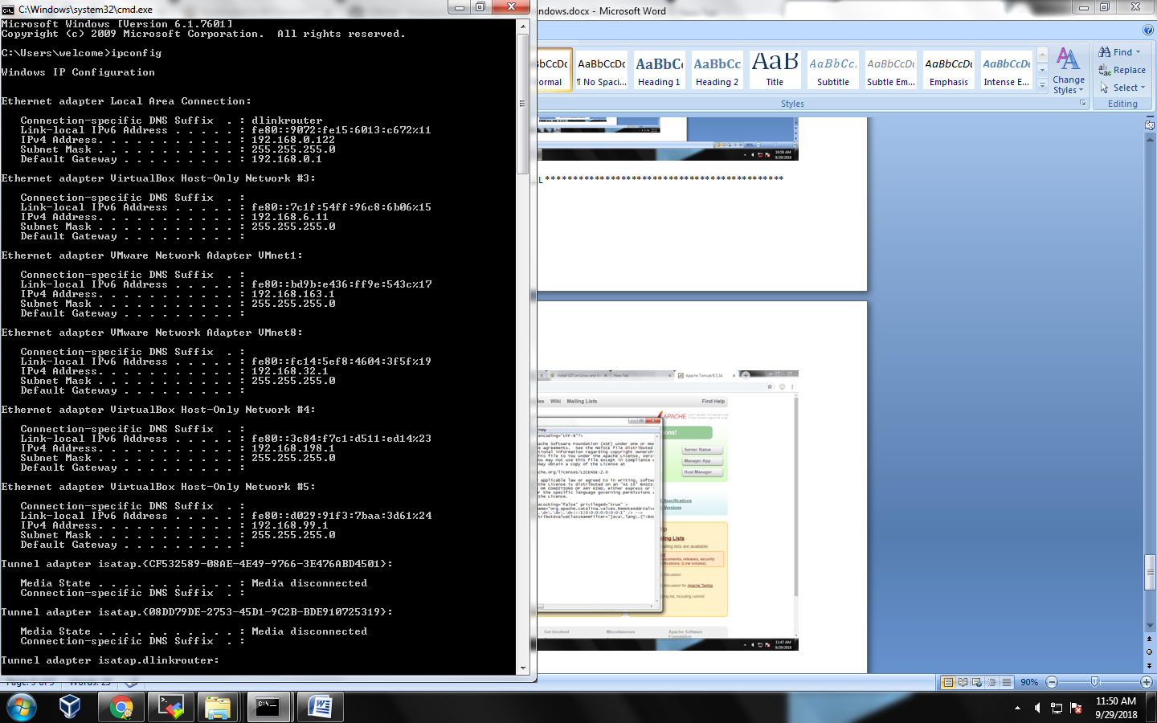

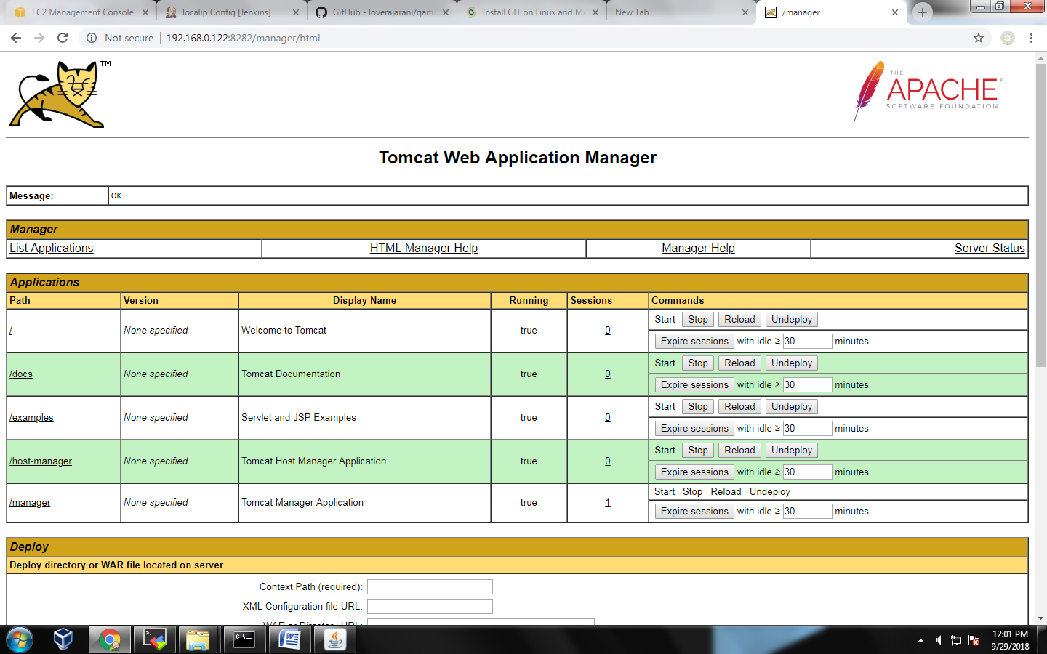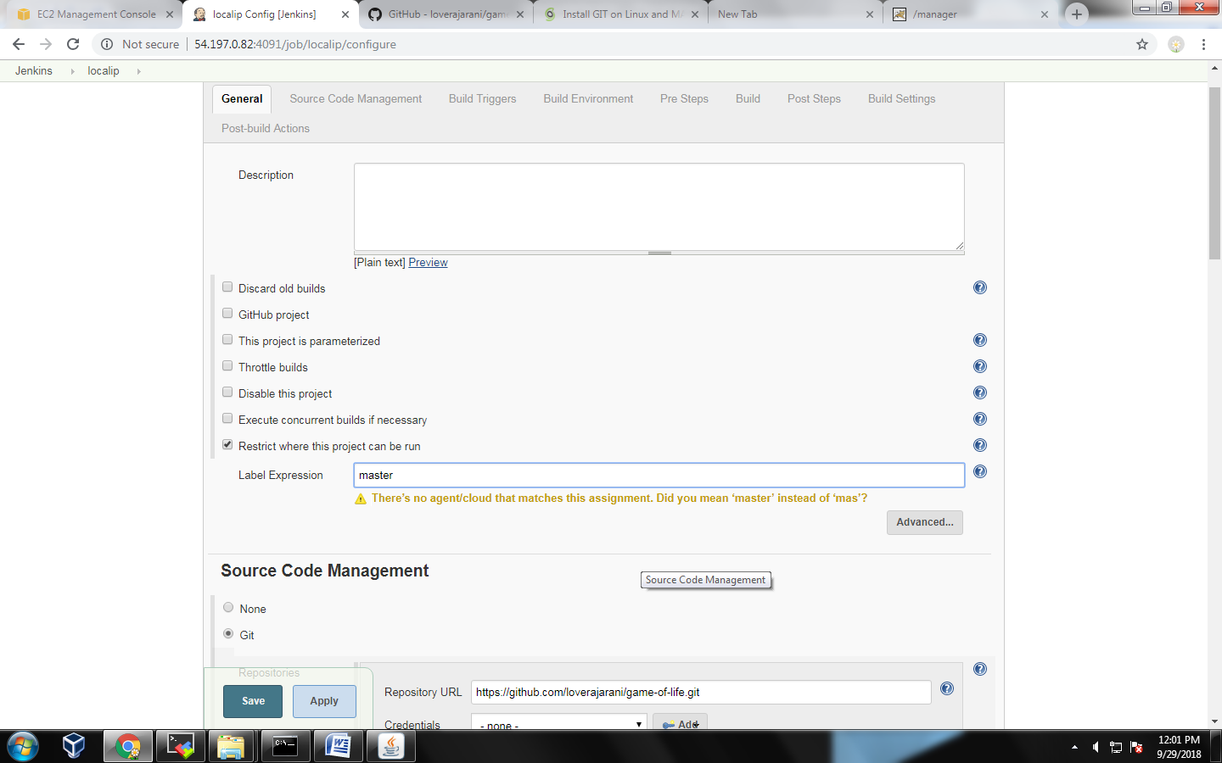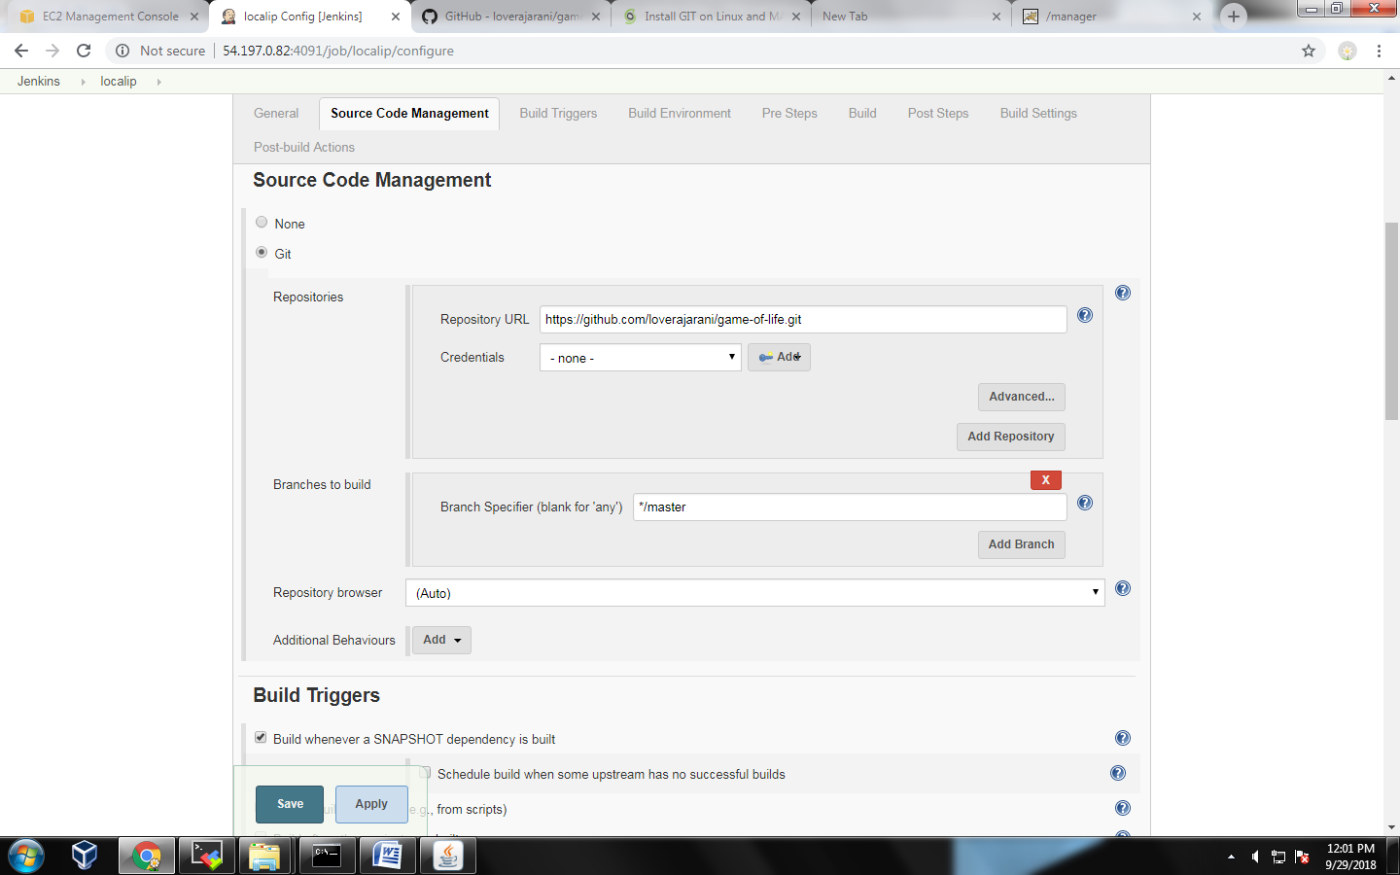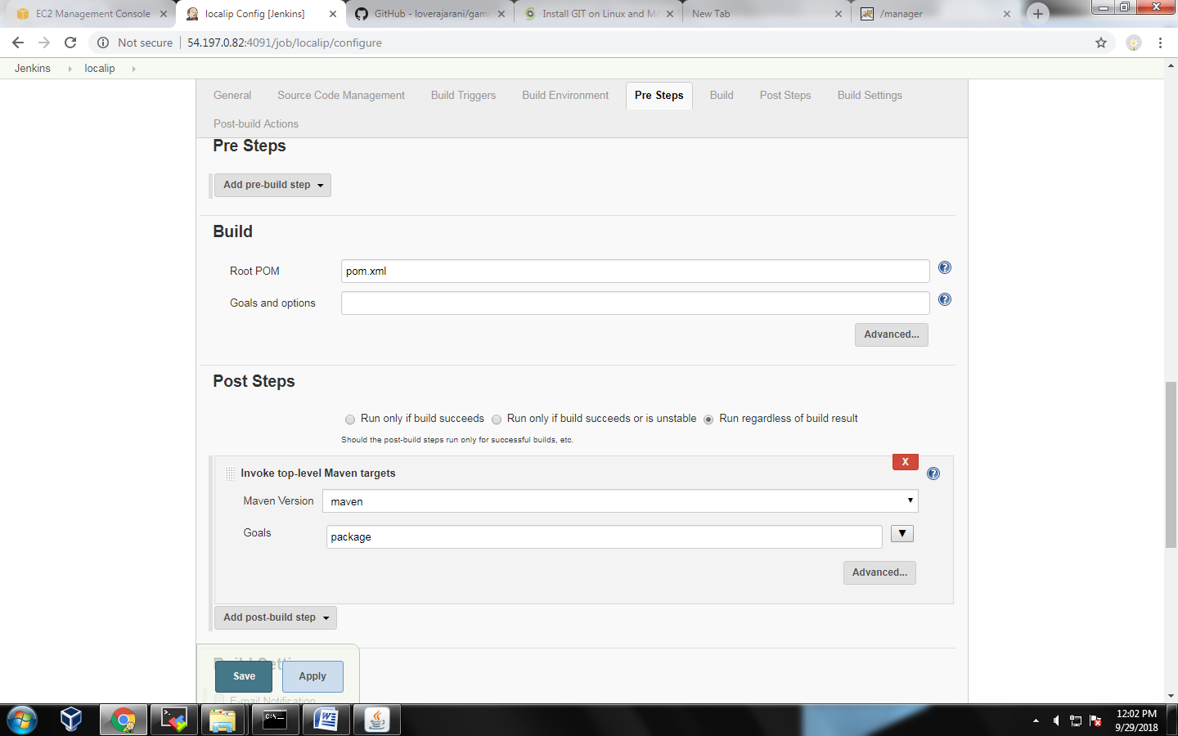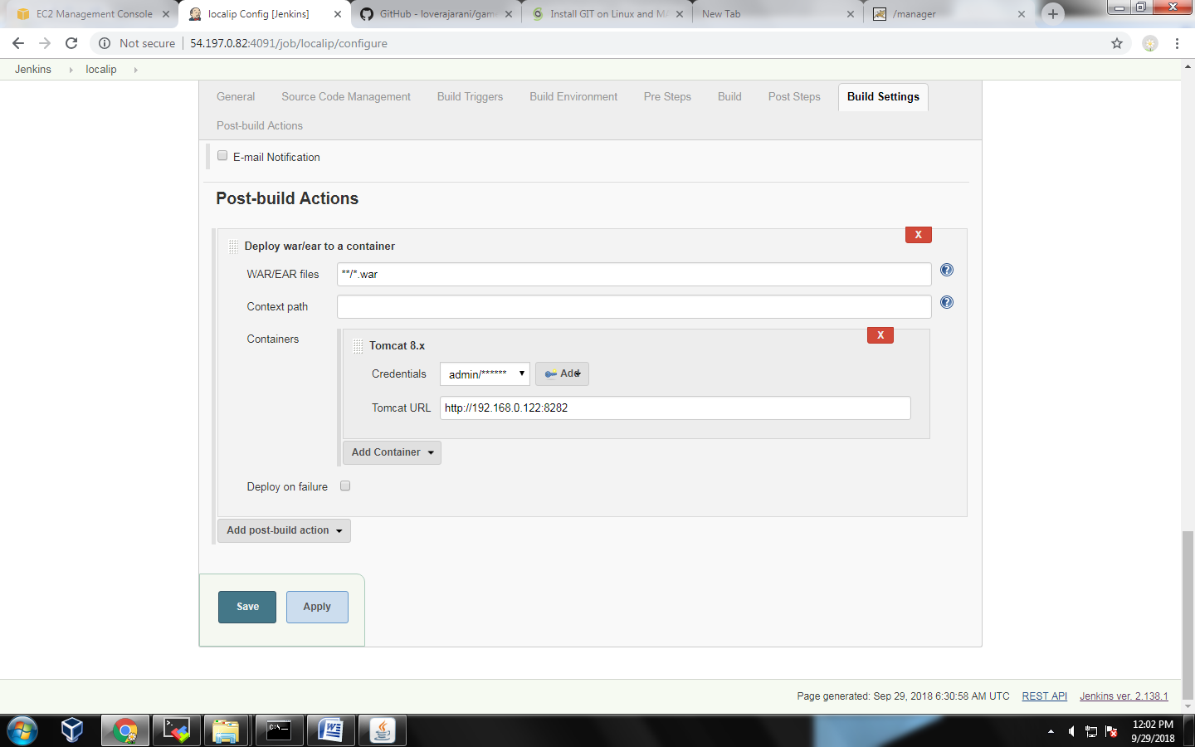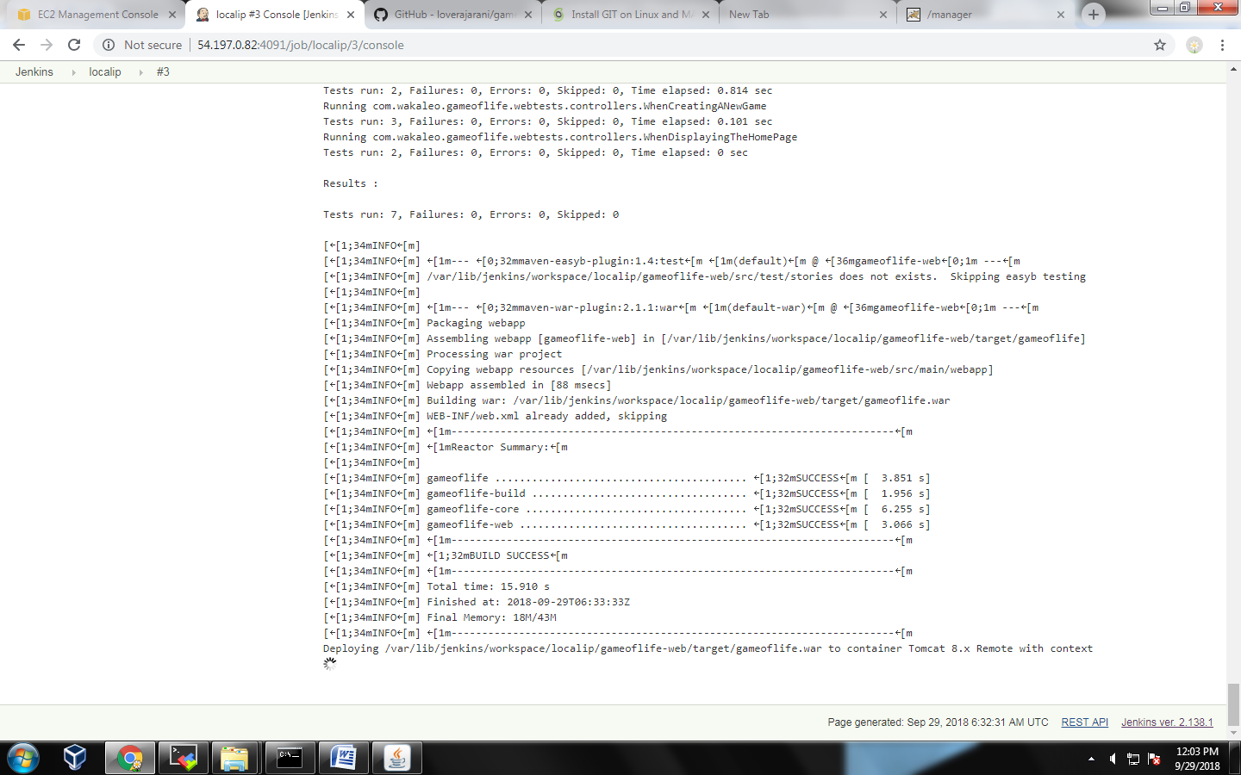

************************* Jenkins on windows ****************************

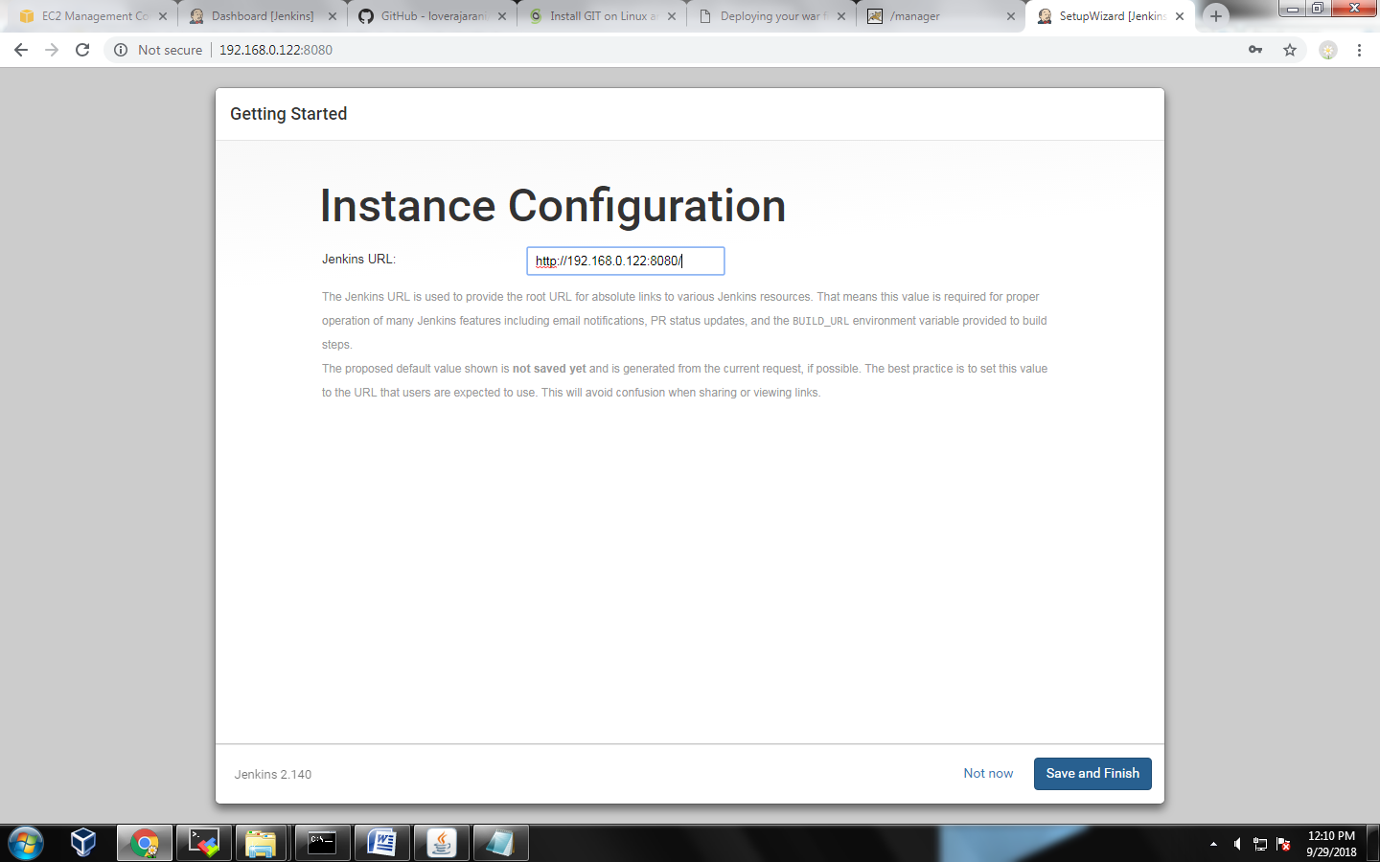

1.git install in windows

2.maven install

<https://maven.apache.org/download.cgi>

choose zip file

extrack on c:\programfiles

* Adding to PATH: Add the unpacked distribution’s bin directory to your user PATH environment variable by opening up the system properties (WinKey + Pause), selecting the “Advanced” tab, and the “Environment Variables” button, then adding or selecting the *PATH* variable in the user variables with the value C:\Program Files\apache-maven-3.5.4\bin. The same dialog can be used to set JAVA_HOME to the location of your JDK, e.g. C:\Program Files\Java\jdk1.7.0_51
* Open a new command prompt (Winkey + R then type cmd) and run mvn -v to verify the installation.

Windows symbol+pause button

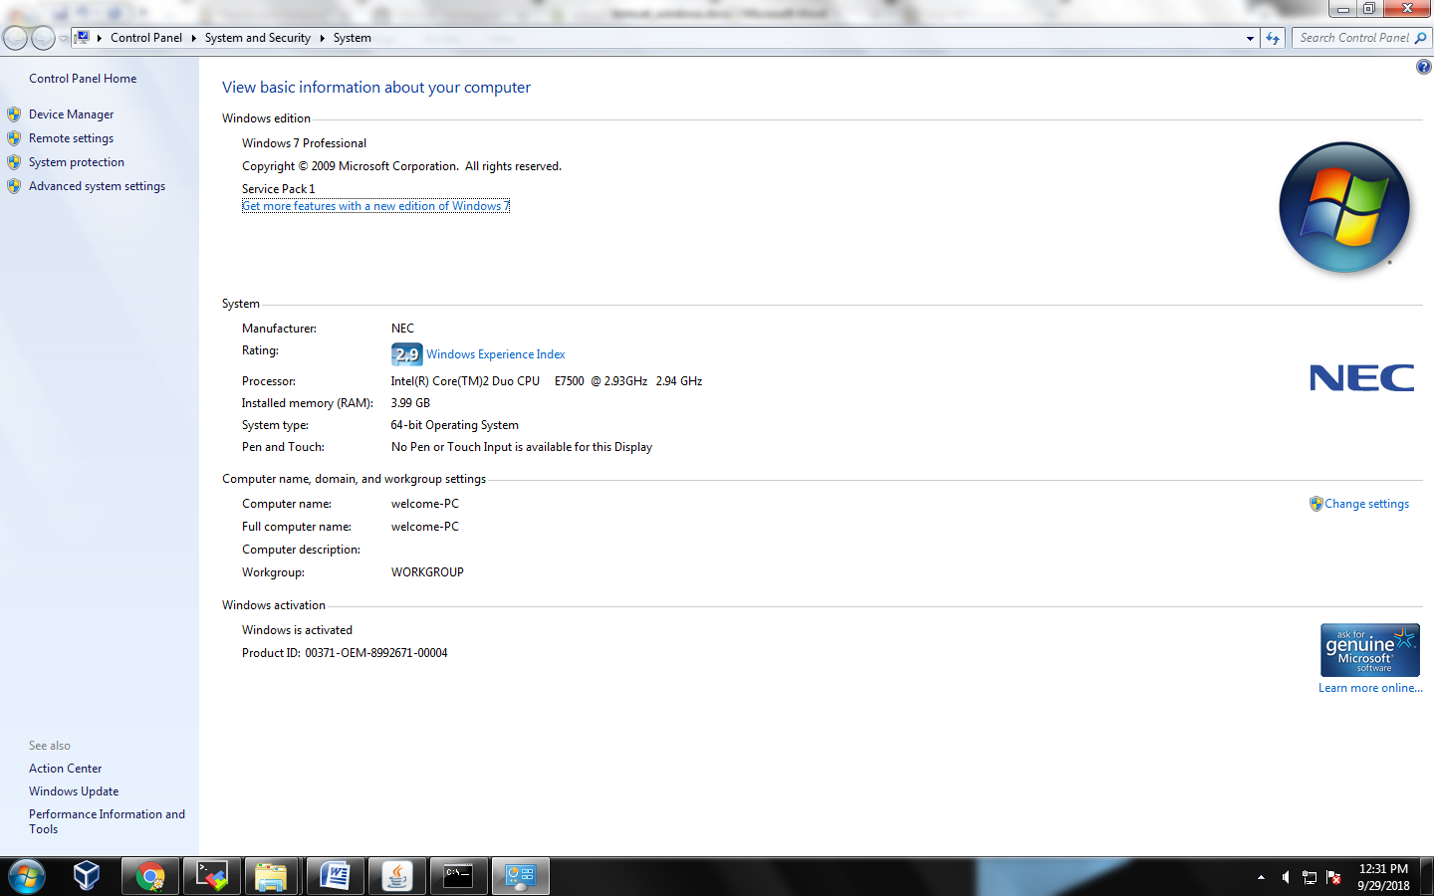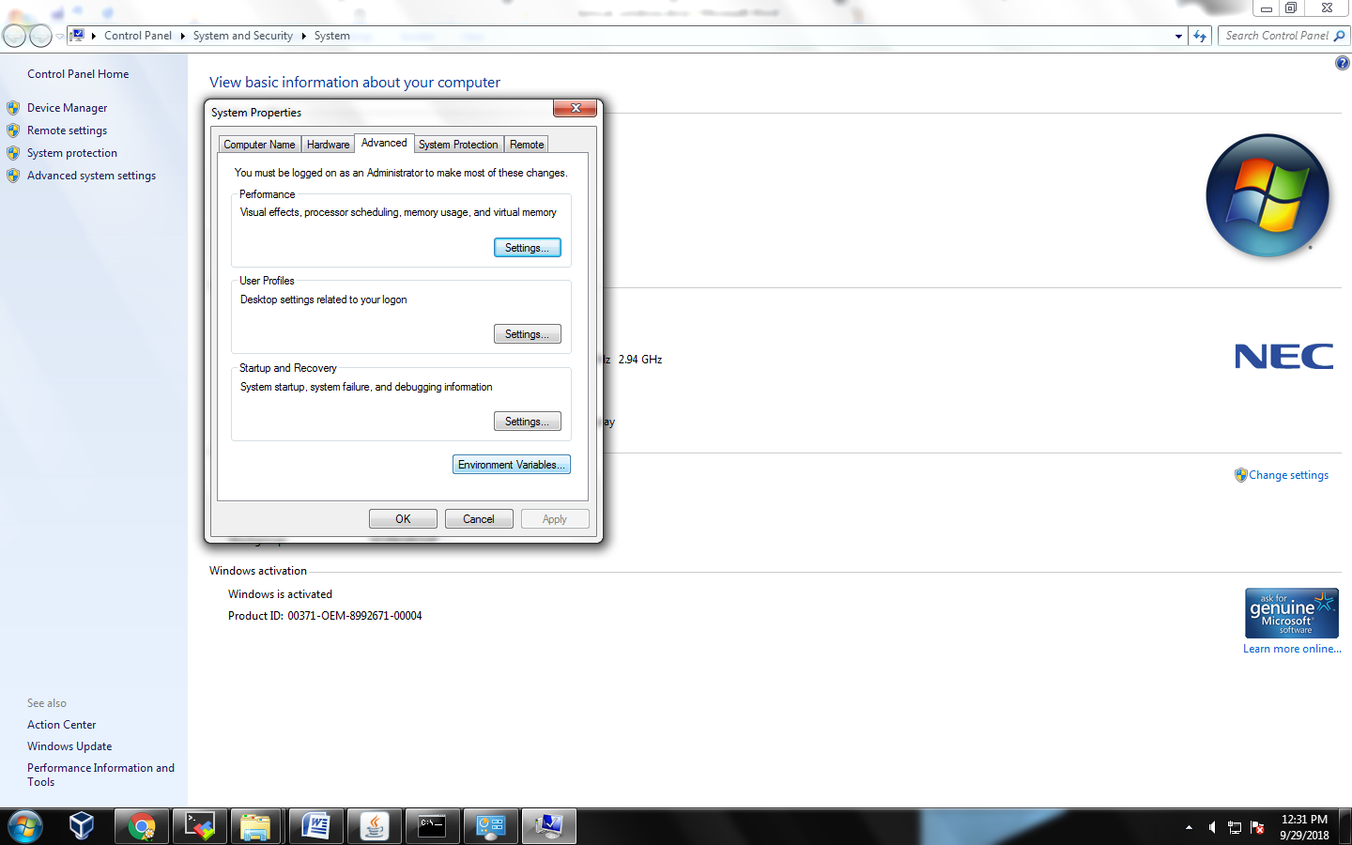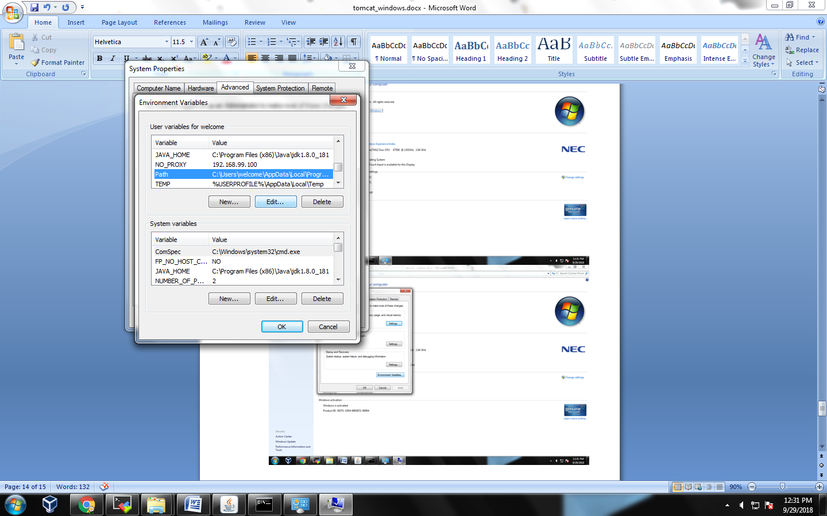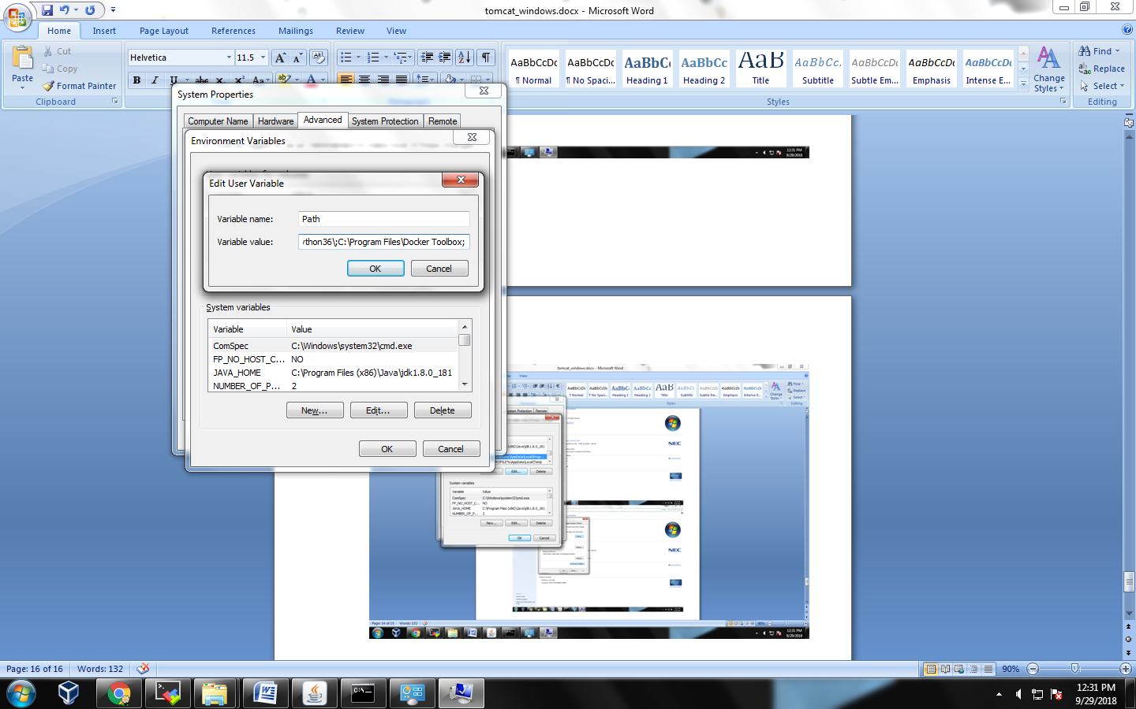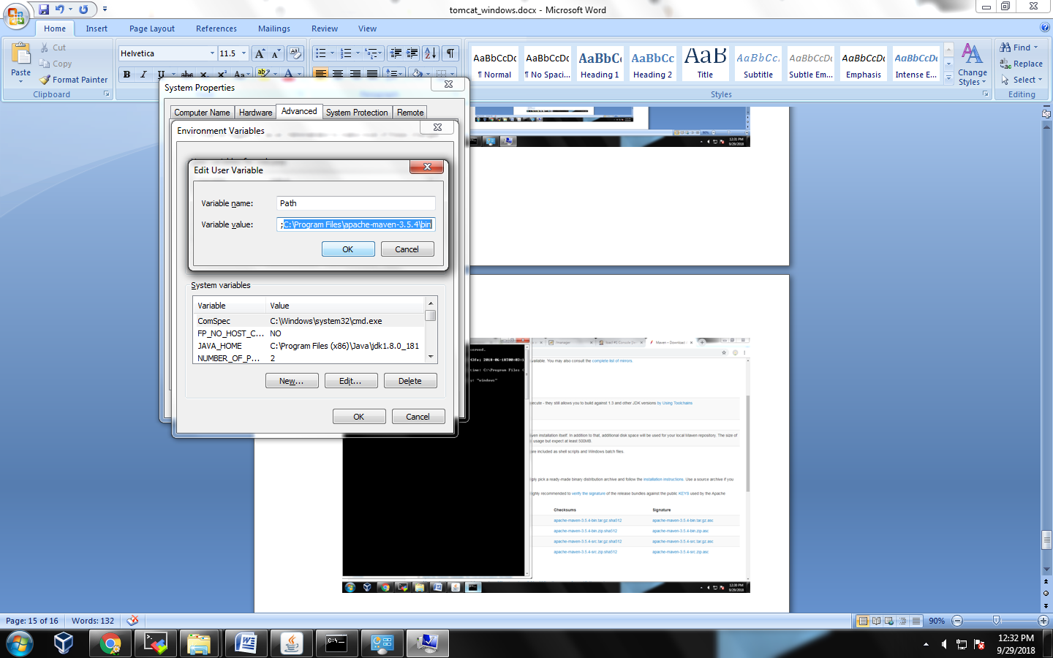

Close cmd and open cmd hit mvn -v

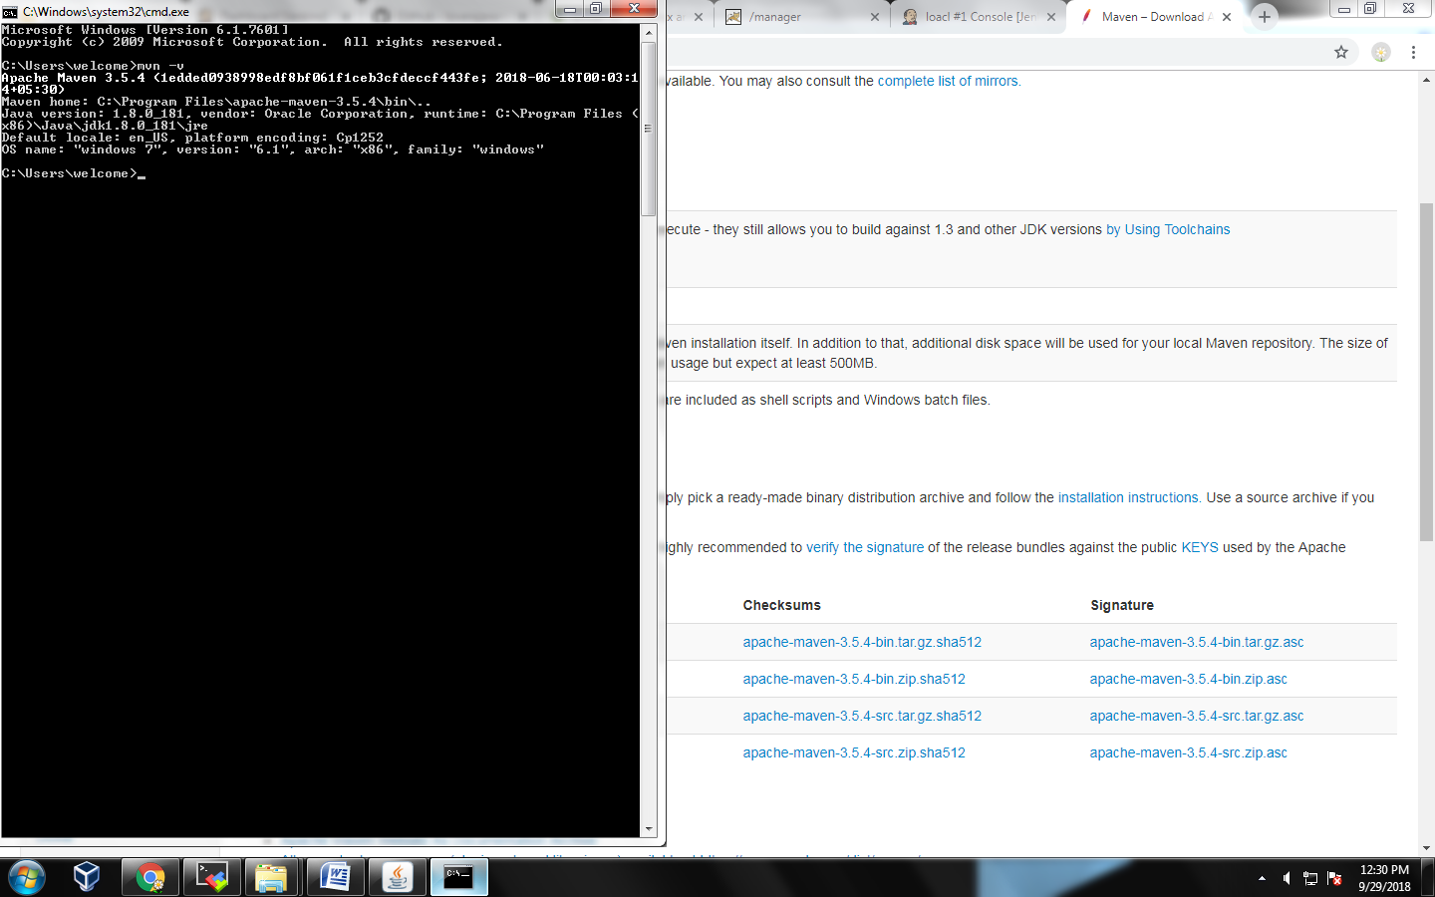

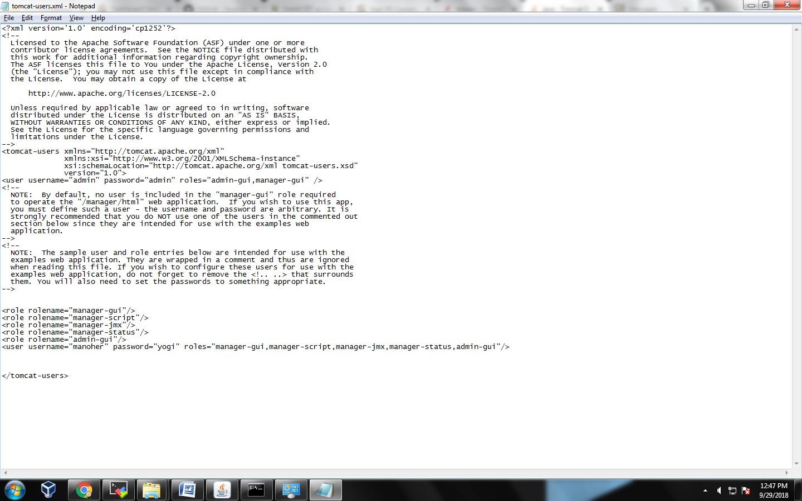

***************** ngetting deploy failure ********************